**Skill Check 5: Write the design specification for the web site.**

Given the audience characteristics from Skill Check #2 and the site architecture diagram from Skill Check #3, create a design specification describing the page layouts, colors and fonts for the web site.

1. Create a wireframe diagram of the home page and one *lowest-level* interior page:
   1. Desktop wireframe:

About page wireframe

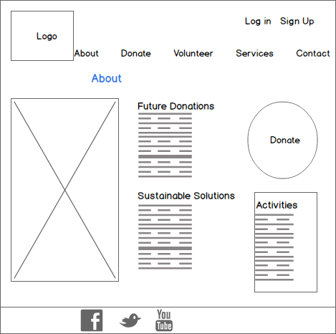

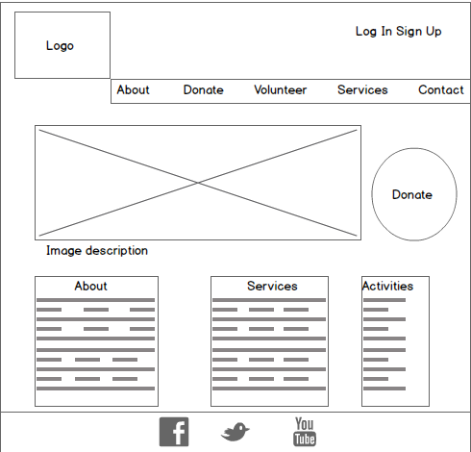 Home page wireframe

* 1. Mobile wireframe:

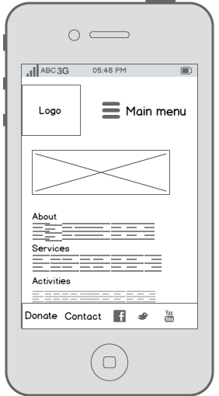

1. Identify the font(s) and color scheme for the web site.
   1. Fonts:

*Be sure the fonts you choose are licensed for use on the web.*

# Helvetica® Neue

# Example

“We clocked 856 affluent pedestrians. Perhaps a re-engineering of your current world view will re-energize your online nomenclature to enable a new holistic interactive enterprise Internet communication solution.”

* 1. Color scheme:

*Create the color scheme using the web tools provided on the class site, take a screenshot, and insert/paste the screenshot into this document.*

